

October 15, 2024

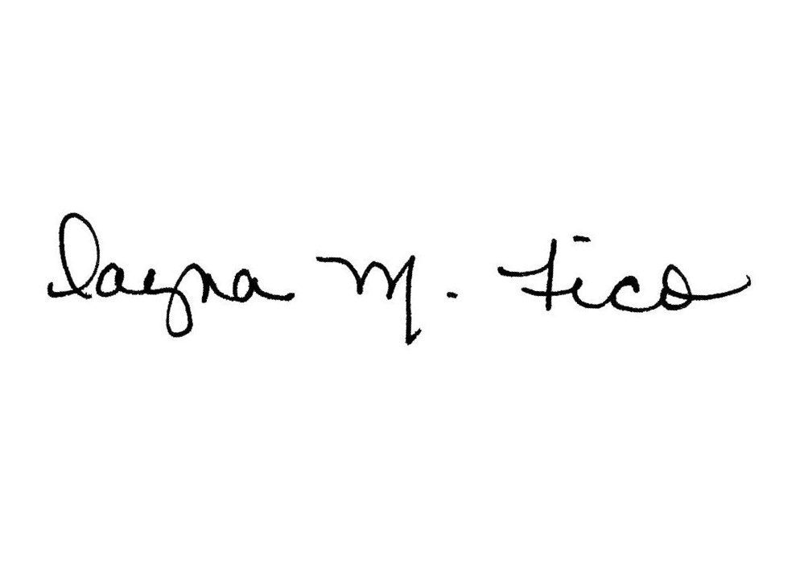
TO: Bradley University Employees

FROM: Dayna Fico, Benefits Administrator

RE: Summary Annual Report 2023

On the left navigation tab you will find the Summary Annual Report for Bradley University for the period of October 1, 2022 through September 30, 2023. A Summary Annual Report provides the financial status of the plan. This information includes assets, administrative expenses, gains or losses, and changes that have occurred in the plan for the previous year. Each year, Bradley University files the report with the Pension and Welfare Benefits Administration and distributes Summary Annual Reports as required by the Employee Retirement Income Security Act of 1974 (ERISA). You have the right to receive a copy of the full annual report, or any part thereof, on request.

As required by the Employee Retirement Income Security Act of 1974 (ERISA), this Summary
Annual Report provides participants and beneficiaries covered under the plan(s) with certain
information that was included in the Annual Report for the plan(s) filed with the Department of
Labor.

Plan 001 TIAA/CREF Retirement Plan - #37-0661494
Benefits under the plan are provided by individually owned fully vested annuity
contracts issued by Teachers Insurance and Annuity Association and College
Retirement Equities Fund.

Plan 002 Tax-deferred Annuity Plan - Participating Individual's Contract
Benefits under the plan are provided by individually owned fully vested annuity
contracts issued by Valic and Fidelity

Plan 502 Group Life Insurance - #37-0661494
The plan has a contract with The Standard to pay all life, accidental death and
dismemberment claims incurred under the terms of the plan. The total premiums
paid for the plan year ending September 30, 2022 were $277,583.

Plan 503 Bradley University's Health Care Plan (EPO) - #37-0661494
Bradley University has committed itself to pay certain medical claims incurred under
the terms of the plan. The plan has a contract with Blue Cross Blue Shield Insurance Company to
pay certain medical claims incurred under the terms of the plan. The total premiums
paid for the plan year ending September 30, 2022 were $411,324.

Plan 504 Group Long Term Disability - #37-0661494
The plan has a contract with The Standard to pay all long-term disability claims incurred under
the terms of the plan. The total premiums paid for the plan year ending
September 30, 2022 were $43,165.

Plan 507 Group Short Term Disability - #37-0661494
The plan has a contract with The Standard to pay all short-term disability claims incurred under
the terms of the plan. The total premiums paid for the plan year ending
September 30, 2022 were $151,797.

Plan 506 Flexible Benefit Plan - #37-0661494
The flexible benefit plan for the plan year ending December 31, 2023 had a total cost
of medical reimbursement of $294,890.

YOUR RIGHTS TO ADDITIONAL INFORMATION: You have the legally protected right to examine at no
cost or obtain copies at a reasonable charge of the latest Annual Report, plan documents, and other
plan information including sales commissions paid by insurance carriers. All the documents filed may
be examined at the Human Resource Department, Bradley University and at the U.S. Department of
Labor in Washington D.C. To obtain a copy of any documents, write to the plan administrator asking
for what you want. The charge to cover copying costs will be $.05 per page for any part thereof.
Request to the Department of Labor should be addressed to: Public Disclosure Room, N4677, Pension
and Welfare Benefit Programs, Department of Labor, 200 Constitution Ave., N.W., Washington, D.C.
20216.

HUMAN RESOURCE DEPARTMENT
1501 WEST BRADLEY AVENUE – PEORIA, IL 61625 – (309) 677-3223 – FAX (309) 677-3867

